**USER WALKTHROUGH - SUPERVISORS**

**BPC PMP MERIT AND CIP AWARD NOTIFICATION PORTAL**

_____________________

Bangladesh Human Resources

**Step 1**

You will receive a system generated e-mail notifying you that the salary action letters for your direct reports are now available in the PMP Merit and CIP Award Notification Portal. Click on the link received or log in to it as below:

<http://pd.bd.chevron.com/MYPD/>

You will see the welcome screen as below;

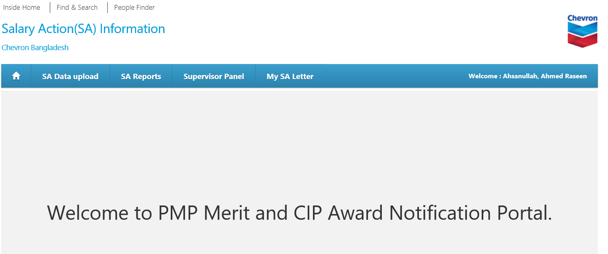

**Step 2**

As a supervisor, you will have access to the “Supervisor Panel” tab to view salary letters for your direct reports and the “My SA Letter” tab to view your own salary action (SA) letter as an employee. The supervisor panel tab is shown in the circled section of the snip below;

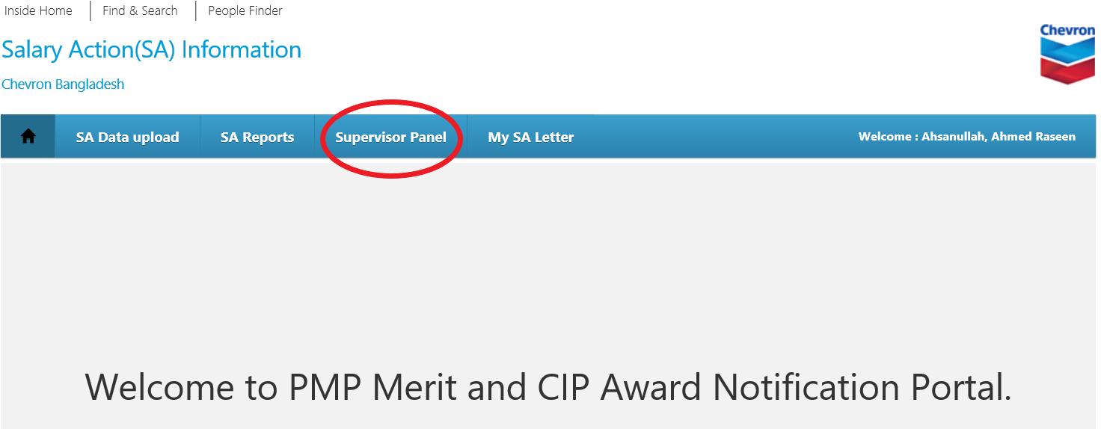

**Step 3**

Once you click on “Supervisor Panel”, it takes you to the following screen containing details of your direct reports.

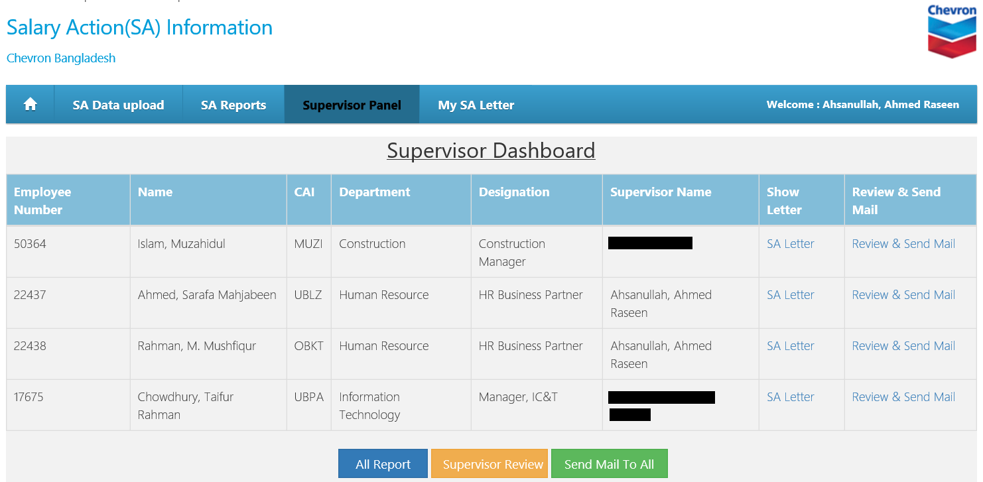

**Step 4**

First check that the list contains names of all your direct reports. If you observe any error, immediately report the incident to HR. Otherwise, click on the SA Letter link for each and every one of your direct reports as snipped below.

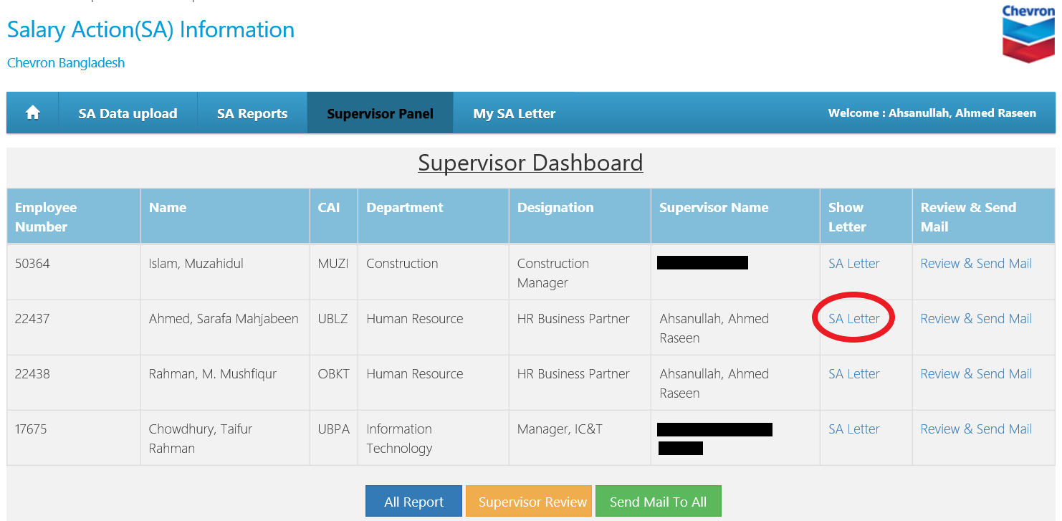

Once you click the link, the PDF format of your direct report’s salary action letter will open as shown below.

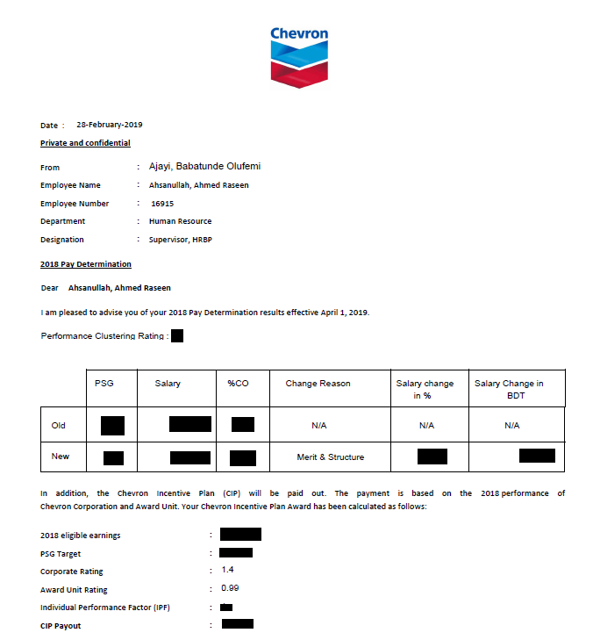

**Step 5**

If everything in the letter looks correct, then next step is to set up a meeting with your direct report to discuss his/her performance and salary action. Once the discussion is complete, you can now click on the “review and send” button as snipped below to forward the salary action letter to your direct report.

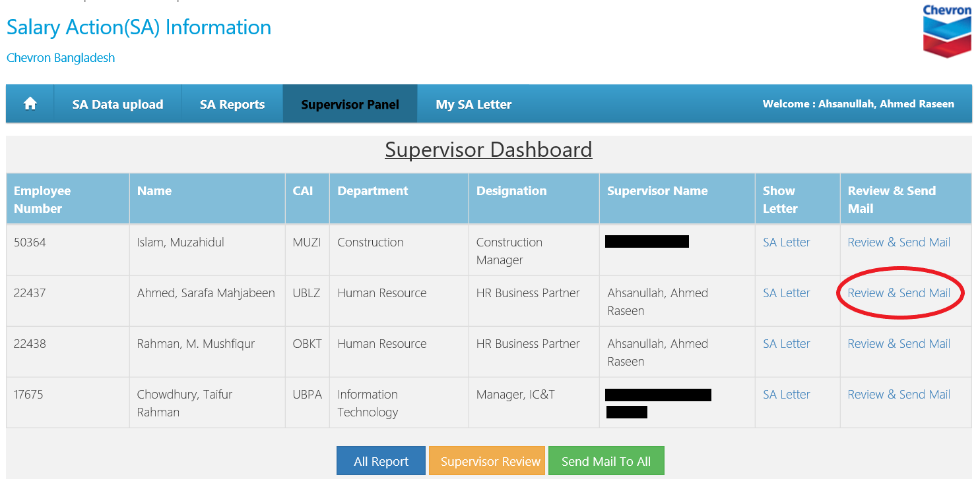

To review the salary action letters for all your direct reports at one go, you have the option of clicking the “All Report” button which generates a PDF version of all the letters for all your direct reports. Once you have reviewed the letters and completed discussions with your direct reports, then click on the “Supervisor Review” button in the same snip below. This logs your review in the system and you can now exercise the “Send Mail To All” button to send the letters to all your direct reports at the same time. A snip of the three buttons is shown below;

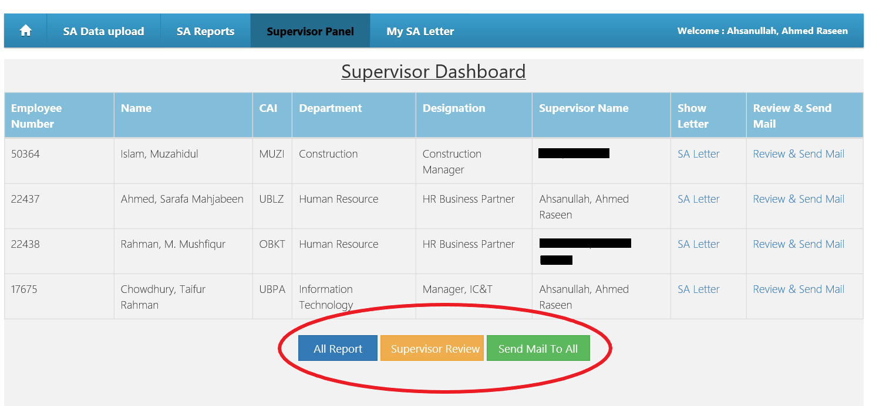

Once you have sent the letter to your direct report, your direct report will receive a system-generated e-mail notifying him/her that the salary action letter is now available in their “My SA Letter” portal for them to view/print as necessary.

Please note that it is mandatory to have a dialogue with your direct report before sending out the salary action letter.